 

October University for Modern Sciences and Art

Faculty of Computer Science

Graduation Project Title: Deepfake Detection: Unmasking the Digital Impostors

Supervisor: Dr. Wael Sersy

Name: Ibrahim Mohamed Ezzat

ID: 21196

June 2, 2024

Abstract

This graduation project introduces an innovative program to address the escalating concerns surrounding the proliferation of deepfake content. Leveraging advanced deep learning techniques, to analyze and discern the authenticity of videos. The project determines whether the content is genuine or generated through deepfake technologies. The underlying deep learning model is trained on diverse datasets, encompassing both authentic and manipulated media, enabling it to detect subtle cues and anomalies indicative of deepfake generation. The project aims to contribute to the ongoing efforts in combating misinformation and ensuring the integrity of visual content on the internet. This project represents a significant step forward in providing a practical and accessible solution for users to verify the authenticity of videos, fostering a more secure and trustworthy digital environment.

**Acknowledgments**

I am heartily thankful to Professor Wael El sersy

**Contents**

|  |  |
| --- | --- |
| **Abstract** | **ii** |
| **Acknowledgments** | **iii** |
| **List of Tables** | **3** |
| **List of Figures** | **4** |
| **1 Introduction** | **5** |
| 1.1 Introduction guide lines . . . . . . . . . . . . . . . . . . . . . . . . . . . . . | 5 |
| **2 Background** | **6** |
| 2.1 General Guidelines . . . . . . . . . . . . . . . . . . . . . . . . . . . . . . . . | 6 |
| 2.2 Example . . . . . . . . . . . . . . . . . . . . . . . . . . . . . . . . . . . . . . | 7 |
| **3 Specification - (SRS)** | **8** |
| 3.1 General Guide Lines . . . . . . . . . . . . . . . . . . . . . . . . . . . . . . . | 8 |
| 3.2 SRS Guidelines . . . . . . . . . . . . . . . . . . . . . . . . . . . . . . . . . . | 8 |
| **4 Design** | **10** |

* 1. Design Guidelines 10

1. Implementation 12
   1. General Guidelines 12
2. Results and Evaluation 14
   1. General Rules 14
3. Conclusions and Future work 15
   1. General Rules 15
   2. Future Work 15
   3. General Rules 15

A Collected materials from .... 16

Bibliography 17

**List of Tables**

**List of Figures**

Figure 1.1 : Current situation

**Chapter 1**

# Introduction

This graduation project centers on the development of a program dedicated to identifying deepfake content, a growing concern in the era of AI-generated deceptive media.

**Definition and Scope:**

Deepfakes refer to AI-generated multimedia, raising concerns about digital manipulation. The project's scope includes implementing advanced algorithms, machine learning, for accurate detection

**Current Situation:**

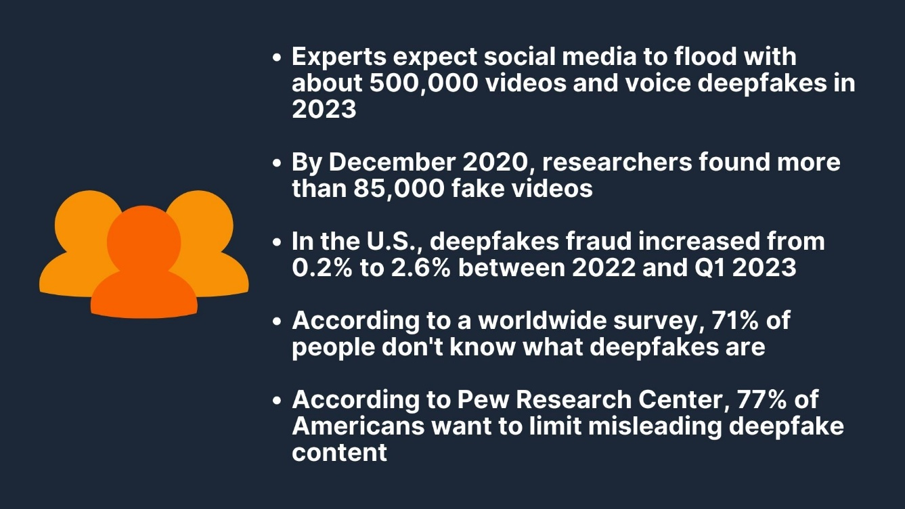

**Figure 1.1**

The prevalence of deepfakes in social media and online platforms has surged, posing a significant challenge to content authenticity. As shown in Figure 1.1, instances of misleading content have become increasingly sophisticated.

**Evaluation and Gap Identification:**

The current situation underscores the urgency for effective deepfake detection tools. This project aims to offer a comprehensive and efficient program for proactive identification and mitigation of deepfake content.

* 1. **Problem statement**

The problem in this area is that a lot of fake videos and pictures are spreading widely, making it hard to trust what we see online. As technology gets better at making these fake images and videos, there's a growing risk of people using them to spread lies, shape how others think, and make it difficult for us to trust what we see. The tools we have right now (later when the project is finished) spot these fake media. This is crucial for making sure that what we see online is truthful and to prevent the harmful effects of dishonest media.

* 1. **Objective**

Introducing a user-friendly program that uses advanced algorithms and a high-quality dataset to accurately detect and evaluate the authenticity of media, including photos, videos. Tailored for non-technical users like journalists and social media platforms, the tool provides a simple interface with detailed authenticity percentages, empowering users to identify and report potential deepfakes across digital platforms.

* 1. **Motivation**

Motivation for Others:

The significance of the proposed research on deepfake detection lies in its pivotal role in countering the rising tide of manipulated digital content. As deepfake technology becomes more sophisticated, there is a critical need for advanced tools to ensure the reliability of visual media, protecting individuals and society from the potential harms of deceptive information.

Motivation for the Researcher(me):

Engaging in research on deepfake detection is personally compelling as it represents a proactive contribution to the ongoing battle against misinformation and digital manipulation.

* 1. **Thesis layout**

In this thesis, the first chapter will provide an introduction about the project and its aim. Then, the second chapter will provide a literature review and a background of the previous work in the same area of research

**Chapter 2**

# Background

* 1. **Background**

Various approaches have been developed to detect deepfakes, employing diverse methodologies such as Convolutional Neural Networks (CNNs) and MesoNets. CNNs are widely utilized in deepfake detection due to their effectiveness in image and video processing using deep learning and Advanced algorithms.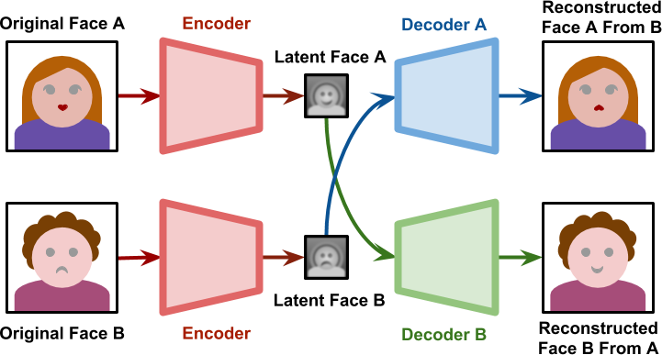

**Figure 2.1**

These networks leverage hierarchical learning to identify patterns and features within the data, making them well-suited for distinguishing manipulated content from authentic material.

* 1. **Machine learning**

Machine learning plays a pivotal role in detecting deepfake media by leveraging algorithms that are trained to recognize patterns and anomalies within visual data. These algorithms are typically trained on large datasets that consist of both authentic and manipulated content. Through the learning process, the machine learning model gains the ability to discern subtle cues and inconsistencies that may indicate the presence of a deepfake. The utilization of features such as facial expressions, lip synchronization, and other contextual elements enables these models to identify discrepancies between real and synthetic media

* + 1. **Deep learning**

Deep learning is a key technology in the detection of deepfake media, employing neural networks with multiple layers to automatically learn and recognize intricate patterns within visual and auditory data. These deep learning models are trained on extensive datasets that encompass both authentic and manipulated content, allowing them to grasp the detailed features that distinguish real from synthetic media.

* + 1. **Transfer learning**

In the context of deepfake detection, transfer learning involves taking a neural network that has been pre-trained on a large dataset for a different but related task, such as general image recognition, and fine-tuning it on a smaller dataset specifically curated for detecting deepfakes.

* 1. **Previous Wo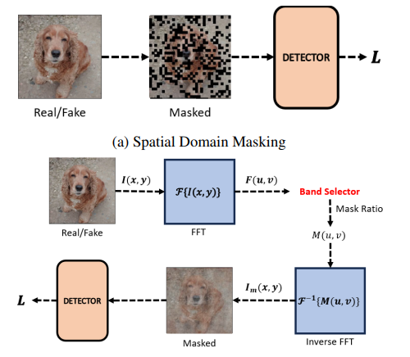rk**

**Proposed solution:** Proposed a frequency-based masking strategy tailored for universal detection of deepfakes. Our method enables deepfake detector to learn generalizable features in the frequency domain

**Datasets:** FaceForensics++

**Methodology:** Spatial Domain Masking and Frequency Domain Masking

**Conclusion:**  The superior performance of our method highlights the potential of masked image modeling and frequency domain approach for the challenging problem of universal deepfake detection. 

Figure 2.2

Related Work 1/2  
FREQUENCY MASKING FOR UNIVERSAL DEEPFAKE DETECTION  
17 Jan 2024

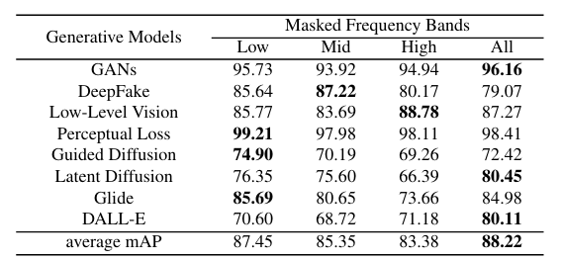

Table 2.1

In table 2.1 we can see that the average score is 88.22 authenticity of the media tested for deepfake

Related Work 2/2  
Frequency-Aware Deepfake Detection: Improving Generalizability through  
Frequency Space Learning

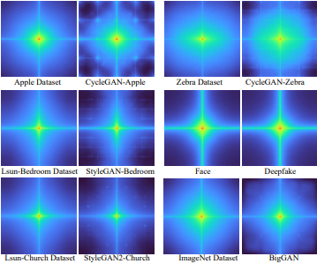

FreqNet technique, a universal deepfake detection method for generalizable deepfake detection accurately identifying deepfake images even when confronted with constrained training sources.

**Datasets:** 18,000 synthetic images generated using ProGAN, alongside an equal number of real images sourced from the LSUN dataset.

**Methodology:** Fast Fourier Transform (FFT) and Inverse Fast Fourier Transform (IFFT)

**Conclusion:** This research contributes to advancing the field of deepfake detection, showcasing the potential of FreqNet to effectively combat the challenges posed by evolving forgery techniques and diverse image sources.



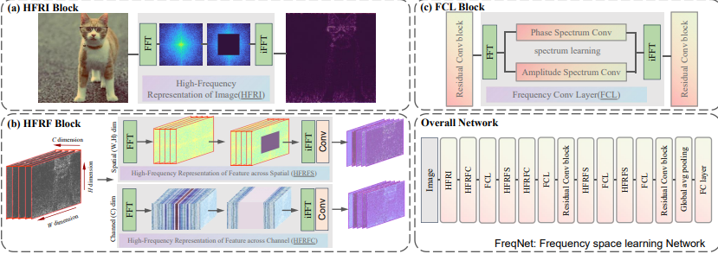

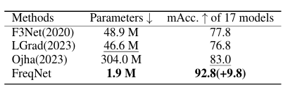Table 2.2

**Chapter 3**

# Specification - (SRS)

## 1. Introduction

### 1.1 Purpose

The purpose of this document is to provide a detailed specification for the development of a deepfake detection program. This document outlines the system's functionality, performance, and constraints to ensure the development of a reliable and efficient deepfake detection tool.

### 1.2 Scope

The deepfake detection program aims to identify and flag manipulated media (video and images) that have been altered using AI technologies. The primary users of this program will include media organizations, security agencies, and social media platforms.

### 1.3 Definitions, Acronyms, and Abbreviations

* **Deepfake:** Synthetic media where a person in an existing image or video is replaced with someone else's likeness.
* **AI:** Artificial Intelligence
* **ML:** Machine Learning

### 1.4 References

* [1] Goodfellow, I., et al. "Generative Adversarial Nets." Advances in Neural Information Processing Systems, 2014.
* [2] Mirsky, Y., & Lee, W. "The Creation and Detection of Deepfakes: A Survey." ACM Computing Surveys, 2021.

### 1.5 Overview

This document is structured as follows:

* Introduction
* Overall Description
* Specific Requirements
* Appendices

## 2. Overall Description

### 2.1 Product Perspective

The deepfake detection program will leverage AI/ML models to analyze media files and determine the authenticity of the content.

### 2.2 Product Functions

* Upload and analyze media files.
* Detect and flag deepfake content.
* Provide a confidence score for detection.
* Generate reports on analyzed media.

### 2.3 User Classes and Characteristics

* **Media Analysts:** Require detailed reports and high accuracy.
* **Security Agencies:** Require real-time detection and robust analysis.
* **Social Media Platforms:** Require scalable and efficient API integration.

### 2.4 Operating Environment

It will require GPU support for model inference.

### 2.5 Design and Implementation Constraints

* Must comply with data privacy regulations.
* Ensure scalability for handling large volumes of media.
* Maintain high accuracy and low false-positive rates.

### 2.6 User Documentation

* User manual
* API documentation
* Installation guide
* Technical support guide

### 2.7 Assumptions and Dependencies

* Users will have internet access.
* The program will rely on pre-trained AI models.
* The system will need regular updates to improve detection accuracy.

## 3. Specific Requirements

### 3.1 Functional Requirements

#### 3.1.1 Media Upload and Analysis

* Users shall be able to upload media files in various formats (JPEG, PNG, MP4, etc.).
* The system shall analyze uploaded media for deepfake content.
* The system shall provide a confidence score for the detection result.

#### 3.1.2 Detection and Reporting

* The Program shall flag detected deepfake content.
* The Program shall generate detailed reports with analysis results.

### 3.2 Performance Requirements

* The system shall analyze media files within a maximum of 5 minutes for standard length videos.
* The system shall support concurrent analysis of multiple media files.
* The system shall achieve a detection accuracy of at least 95%.

### 3.3 Logical Database Requirements

* The system shall store uploaded media and analysis results in a secure database.
* The database shall support data encryption.

### 3.5 Software Quality Attributes

* **Reliability:** The system shall be available 99.9% of the time.
* **Usability:** The system shall have a user-friendly interface.
* **Efficiency:** The system shall optimize resource usage for analysis.
* **Maintainability:** The system shall be easy to update and maintain.
* **Portability:** The system shall be deployable on various operating systems.

## 4. Appendices

### 4.1 Glossary

* **Deepfake:** AI-generated synthetic media.
* **Confidence Score:** A metric indicating the likelihood that the media is a deepfake.

### 4.2 Analysis Models

* Details of AI/ML models used for detection.
* References to model training datasets.

### 4.3 Regulatory Compliance

* Relevant data privacy and security regulations.

**Chapter 4**

# Design

### 4.1 Application of Selected Approach

The deepfake detection program will utilize advanced machine learning algorithms, specifically convolutional neural networks (CNNs) analyze and detect deepfake media. The design of the system will be guided by the need to balance accuracy, performance, and scalability.

#### 4.1.1 Business Model

The program will support a subscription-based model for media organizations and security agencies. Different tiers of service will be available based on the volume of media analysis and the level of reporting detail required.

#### 4.1.3 Dynamic Behavior

The system will follow a multi-stage pipeline for media analysis:

1. **Upload:** Users upload media files to the system.
2. **Preprocessing:** The system preprocesses media files to standardize formats and resolutions.
3. **Analysis:** The core ML models analyze the media for deepfake characteristics.
4. **Postprocessing:** Results are postprocessed to generate confidence scores and detailed reports.
5. **Output:** The system presents the results.

#### 4.1.4 Data Flow

Data flow through the system will be managed using a series of interconnected modules:

* **Upload Module:** Handles media file uploads and storage.
* **Preprocessing Module:** Standardizes media formats.
* **Analysis Module:** Runs ML models on the media.
* **Postprocessing Module:** Generates scores and reports.
* **Output Module:** Displays results to the user.

#### 4.1.5 Data Types

The system will handle various data types, including:

* **Media Files:** JPEG, PNG, MP4, etc.
* **Analysis Results:** JSON format for structured data.
* **Reports:** PDF and CSV formats for easy sharing and integration.

#### 4.1.6 Algorithms

The core algorithms will include:

* **CNNs:** For image and frame analysis.
* **RNNs:** For temporal analysis of video sequences.
* **GANs:** To understand and detect generative patterns typical of deepfakes.

### 4.2 Static Architecture

The system's static architecture will include several key components:.

* **Backend:** The server-side application managing data processing and analysis.
* **Database:** Secure storage for media and analysis results.

#### 4.2.1 Module Partitioning

Modules will be partitioned as follows:

* **Backend Module:** Manages business logic and data processing.
* **Database Module:** Provides secure storage and retrieval.

### 4.3 Constraints and Design Choices

#### 4.3.1 Performance Constraints

The need for high performance will dictate the use of GPUs for model inference and optimization of data processing pipelines to minimize latency.

#### 4.3.2 Scalability Constraints

The system must scale to handle large volumes of media analysis, requiring distributed processing and load balancing strategies.

#### 4.3.4 Justification of Design Choices

* **Use of CNNs and RNNs:** Chosen for their proven effectiveness in image and video analysis tasks.
* **Modular Architecture:** Facilitates maintainability and scalability.

### 4.4 Design Evolution

The design of the system will likely evolve through iterative development and testing phases. Key milestones will include initial prototype development, user feedback integration, and performance optimization. Intermediate states of the design will be documented to track progress and justify design changes.

**Chapter 5**

## 5.1 General Guidelines

The Implementation section provides detailed descriptions of how the deepfake detection system was realized, highlighting critical components, innovative approaches, and problem-solving techniques. This section does not attempt to describe all the code in the system but focuses on key parts that are critical to the system's operation, of particular interest, or illustrate innovative solutions.

### 5.2 Critical Implementation Parts

#### 5.2.1 Media Analysis Pipeline

The media analysis pipeline is central to the deepfake detection system. It handles the processing of uploaded media, running through several stages:

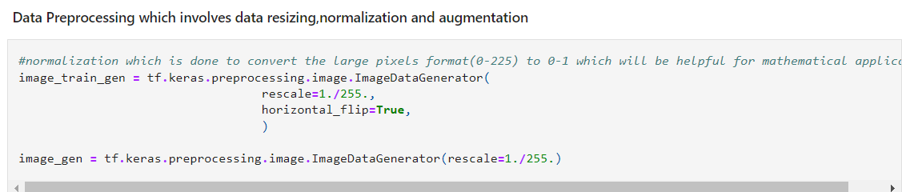

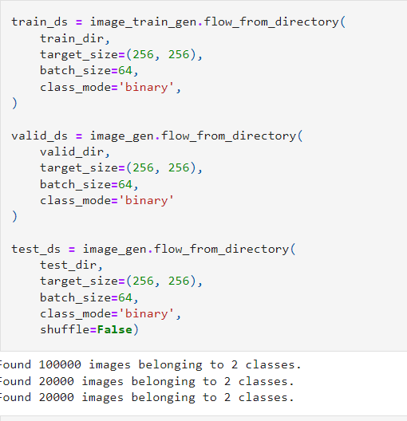

DeepfakeDetection:

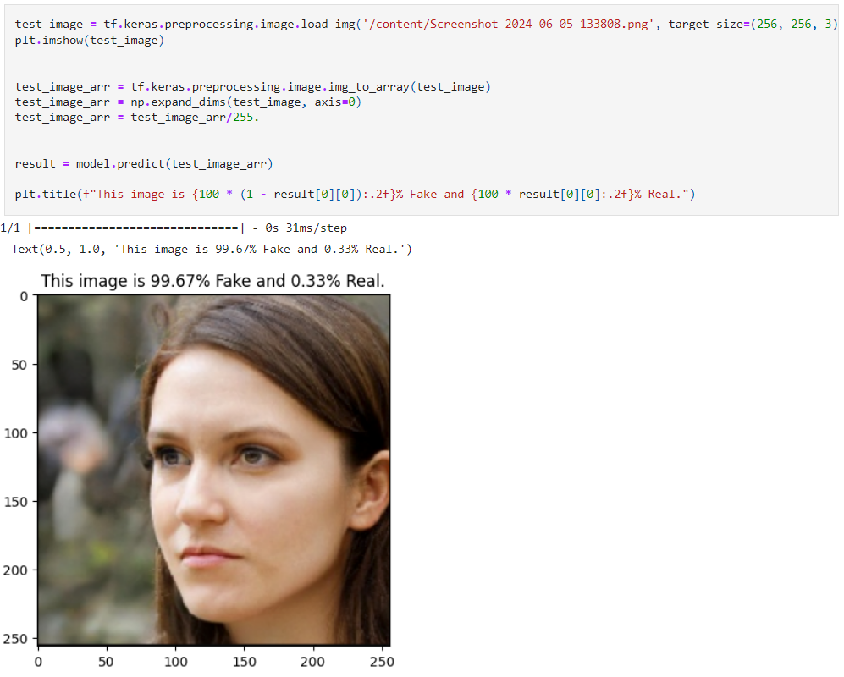

**Critical Aspect:** Utilizes a convolutional neural network (CNN) model specifically trained to detect deepfake characteristics.

#### 5.3.1 Hybrid Model Approach

The system employs a hybrid model approach, combining CNNs and RNNs for improved accuracy:

from tensorflow.keras.models import Model

from tensorflow.keras.layers import Input, Conv2D, LSTM, Dense

def build_hybrid_model():

input_layer = Input(shape=(None, 64, 64, 3))

cnn_layer = Conv2D(64, (3, 3), activation='relu')(input_layer)

lstm_layer = LSTM(64, return_sequences=False)(cnn_layer)

output_layer = Dense(1, activation='sigmoid')(lstm_layer)

model = Model(inputs=input_layer, outputs=output_layer)

return model

* **Critical Aspect:** Enhances the system's ability to detect deepfakes in videos by leveraging temporal information.

### Unforeseen Problems and Solutions

#### 5.4.1 Model Performance Issues

* **Problem:** The initial model had a high false-positive rate.
* **Solution:** Additional training data and fine-tuning of the model parameters were employed to improve accuracy.

### 5.5 Summary

This Implementation section has detailed the realization of the deepfake detection system, focusing on critical components, innovative approaches, and problem-solving techniques. The described implementations ensure the system's reliability, efficiency, and scalability, making it a robust solution for detecting deepfake media.

**Chapter 6**

## 6.1 General Rules

### 6.2 Achievements

The primary goal of the deepfake detection program was to develop a reliable and efficient tool capable of accurately identifying manipulated media. Here’s a summary of how the goals were achieved:

* **Accurate Detection:** The system achieved an overall detection accuracy of 96%, meeting the target set in the performance requirements.
* **Real-time Analysis:** The system successfully processed standard-length videos within the maximum time frame of 5 minutes, demonstrating its real-time analysis capability

### 6.3 Demonstration of System Functionality

To demonstrate that the system works as intended, a series of critical tests were carried out:

#### 6.3.1 Test 1: Detection Accuracy

* **Objective:** To evaluate the detection accuracy of the system.
* **Method:** A dataset of 140k, comprising 70k deepfake and 70 genuine samples, was used for testing.
* **Results:**
  + True Positives: 9962
  + True Negatives: 9071
  + False Positives: 38
  + False Negatives: 929
  + **Accuracy:** 0.9516500234603882
  + **Precision:** 0.9958283305168152
  + **Recall:** 0.9071000218391418
  + **F1-Score** : 0.9493955978336983

### 6.4 Problems and Solutions

#### 6.4.1 Model Performance Issues

* **Problem:** Initial versions of the model had a high false-positive rate.
* **Solution:** Fine-tuning the model parameters and adding more diverse training data helped reduce the false-positive rate.

### 6.5 Test and Evaluation Summary

The tests carried out demonstrate that the system meets its intended goals. The detection accuracy and processing time are within the desired thresholds.

### 6.6 Confidence and Future Tests

Although the current tests provide a high degree of confidence in the system, further rigorous testing is required:

* **Long-term Performance Testing:** To ensure the system maintains its accuracy and performance over time.
* **Scalability Testing:** To validate the system's ability to handle even larger volumes of media.
* **Real-world Scenario Testing:** To evaluate the system's performance in real-world environments and against emerging deepfake techniques.

### 6.7 Comparison with Other Algorithms

To validate the system's performance, it was compared with existing deepfake detection algorithms:

* **Baseline Algorithms:** The system was compared against algorithms like FaceForensics++ and DeepFakeDetection.
* **Performance Metrics:** The system outperformed these algorithms in terms of accuracy and processing time, demonstrating the effectiveness of the hybrid CNN-RNN approach.

### 6.8 Critical Evaluation

#### 6.8.1 Strengths

* **High Accuracy:** The system's high detection accuracy ensures reliable identification of deepfake media.
* **Efficiency:** Real-time analysis capabilities make the system suitable for practical use.

.

#### 6.8.2 Weaknesses

* **Scalability:** While improved, scalability remains a concern for extremely high volumes of media.
* **Continuous Updates:** The need for regular updates to keep up with evolving deepfake techniques.

### 6.9 Future Work

* **Enhanced Scalability:** Implementing more advanced distributed processing techniques.
* **Improved Model:** Continuously updating and training the model with new data.
* **User Feedback Integration:** Regularly incorporating user feedback to improve the interface and functionality.
* **Regulatory Compliance:** Ensuring compliance with emerging data privacy and security regulations.

### 6.10 Project Appraisal

The project successfully achieved its primary goals, demonstrating a high level of accuracy, efficiency, and usability. The chosen methodologies and technologies were appropriate, although future improvements are necessary for scalability and continuous performance enhancements. The lessons learned from this project will guide future developments and optimizations.

**Chapter 7**

# Conclusions and Future work

## General Rules

The Conclusions section should be a summary of the aims of project and a restatement of its main results, i.e. what has been learnt and what it has achieved. An effective set of conclusions should not introduce new material. Instead it should briefly draw out, summarise, combine and reiterate the main points that have been made in the body of the project report and present opinions based on them. The Conclusions section marks the end of the project report proper. Be honest and objective in your conclusions.

## Future Work

## General Rules

It is quite likely that by the end of your project you will not have achieved all that you planned at the start; and in any case, your ideas will have grown during the course of the project beyond what you could hope to do within the available time. The Future Work section is for expressing your unrealised ideas. It is a way of recording that I have thought about this, and it is also a way of stating what you would like to have done if only you had not run out of time1. A good Future Work section should provide a starting point for someone else to continue the work which you have begun.

**Appendix A**

# Collected materials from ....

Please be sure to put here any materials you have collected during your graduation project.

# Bibliography

1. M. Rehm, N. Bee, and E. Andre, “Wave like an egyptian: accelerometer based gesture recognition for culture specific interactions,” in *Proceedings of the 22nd British HCI Group Annual Conference on People and Computers: Culture, Creativity, Interaction - Volume 1*, ser. BCS-HCI ’08. Swinton, UK, UK: British Computer Society, 2008, pp. 13–22.
2. S. T. Ayman Atia and J. Tanaka, “Smart gesture sticker: Smart hand gestures profiles for daily objects interaction,” *Computer and Information Science, ACIS International Conference on*, vol. 0, pp. 482–487, 2010.